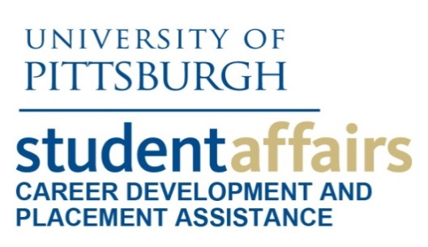
DiscoverU Day: Sample Schedule

SITE INFORMATION

Location: School of Health and Rehabilitation Sciences (SHRS)
Number of students: 40 (2 rotating groups of 20)
Target audience: Students interested in health-related fields
Description: Discover professions in Rehab Science by meeting School of Health and Rehabilitation Science students and participating in hands-on activities such as learning life-saving skills like intubation and learning how to use adaptive healthcare equipment. Have fun and learn about Occupational Therapy, Emergency Medicine, Rehabilitation Counseling, Health Information Management and more!

AGENDA

1:00 p.m. SHRS School Overview

1:10 p.m. Rehabilitation Counseling
- SHRS students will offer a brief panel discussion providing an overview of the rehabilitation counseling graduate program. Panelists will be three Master's level graduate students and the discussion will be moderated by a doctoral level student. Panel will be followed by a brief Q&A.

1:30 p.m. Occupational Therapy
- Occupational Therapy presents “ADAPT IT.” During this hands-on session you will learn about and use adaptive equipment for dressing, bathing, feeding, and cooking, and make a functional splint.
2:00 p.m. Health Information Management
- This session will include an overview of Health Information Management and introduce you to different interactive resources to learn about the many career paths related to the field of Health Information Management.

2:20 p.m. Emergency Medicine
- This session will provide a brief overview of the Emergency Medicine Program. You will get hands-on experience with different skills performed by paramedics, including CPR, airway management, cardiac monitoring, and vascular access.

STUDENT FEEDBACK

“The staff was well put together, was personable with us, and also made efforts to get to know students and answer questions throughout. The demonstrations were awesome.”

“I learned a lot about the School of Health and Rehabilitation Sciences that I had not previously known. I am definitely more interested in pursuing a major and career in one of these areas after attending.”

“It was informative and fun! The best part was how interactive the experience was- I felt like we got a glimpse into so many areas of the school and labs.”

